SFMC: Fire an event API
It allows an external event to post an event to SFMC
Approach Details:
In this approach, we are leveraging the Fire Event API to trigger event in SFMC in real time. The fire event API allows external systems such as AJO to post an event directly in SFMC. Within AJO, custom actions are configured to trigger through a journey, which then calls the fire event API and passes the necessary data.
On the SFMC side, an API event definition is created and linked to a Data extension. When the AJO invokes the fire event API, it sends the event payload along with the event definition key. This automatically inserts the data into the linked data extension and simultaneously triggers the associated journey.
Unlike the data extension API approach, there is no need for a schedule journey. The journey is triggered immediately whenever the fire event API is called, ensuring real time execution.

Salesforce documentation Reference:
https://developer.salesforce.com/docs/marketing/marketing-cloud/references/mc_rest_interaction/postEvent.html
High level flow:
AJO -> Custom Action -> Journey – Fire event API -> SFMC event entry -> contact injected -> Journey executes.
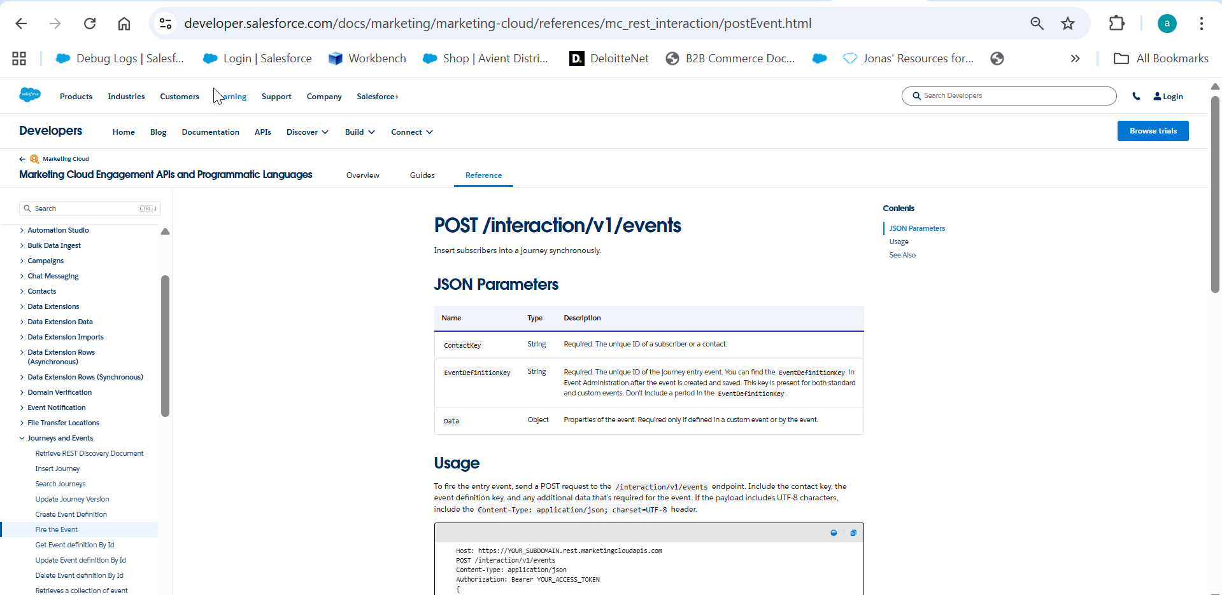

API Details for the POC:
POST /interaction/v1/events
End point: https://mcs8hw9n1wf8nz625j-qdzmgxq0y.rest.marketingcloudapis.com/interaction/v1/events

Body:
{
"ContactKey": {
"toBeMapped": true,
"dataType": "string",
"label": "reltio id"
},
"EventDefinitionKey": "APIEvent-c0402392-f0d5-7566-6731-ffd9d4110220",
"Data": {
"Reltioid": {
"toBeMapped": true,
"dataType": "string",
"label": "Reltio id"
},
"Reltio Email Address": {
"toBeMapped": true,
"dataType": "string",
"label": "email id"
}
}
}
Authentication details:
{
"type": "customAuthorization",
"authorizationType": "Bearer",
"endpoint": "https://mcs8hw9n1wf8nz625j-qdzmgxq0y.auth.marketingcloudapis.com/v2/token",
"method": "POST",
"headers": {
"Content-Type": "application/json"
},
"body": {
"bodyType": "json",
"bodyParams": {
"grant_type": "client_credentials",
"client_id": "psd2h8z765t083jimoxuzxi4",
"client_secret": "********"
}
},
"tokenInResponse": "json://access_token"
}

Step 1: Create event definition in SFMC
Define an API event in SFMC, Link this event to a specific data extension that will the ingested records. The event definition will generate an Event Definition Key, which is required to fire events through the API

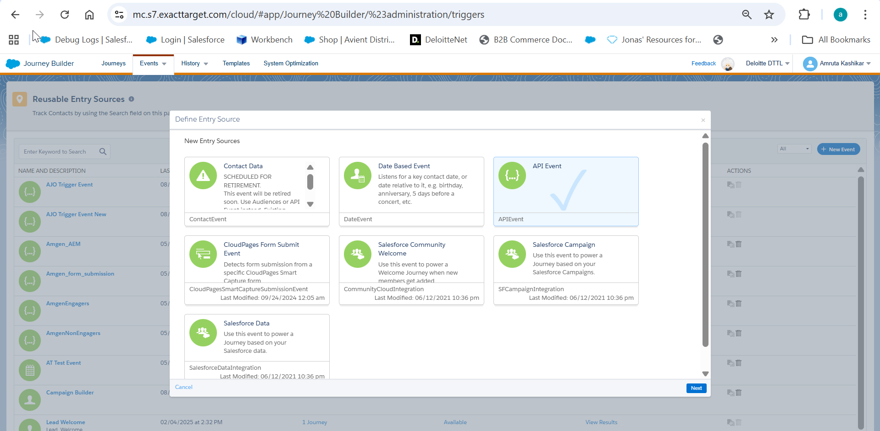

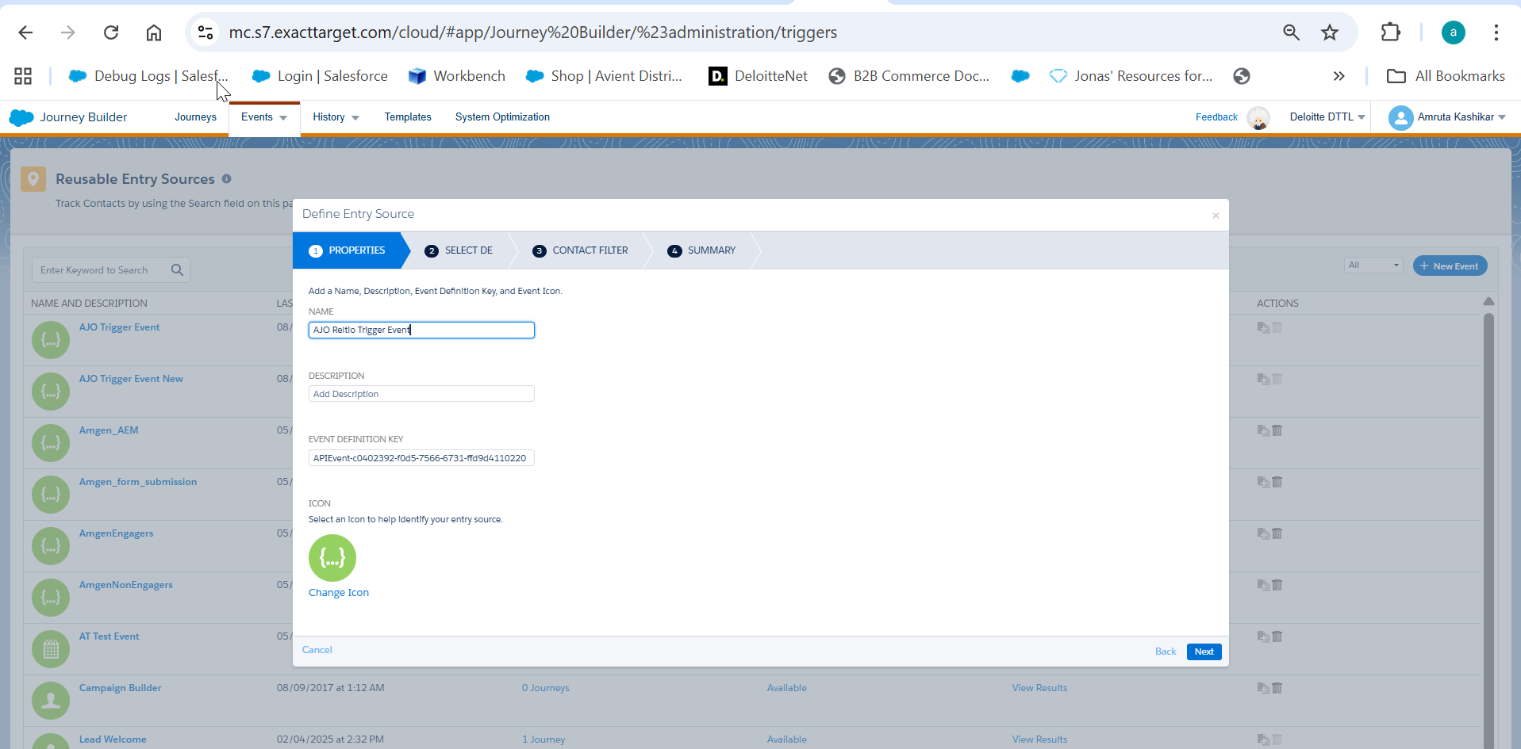

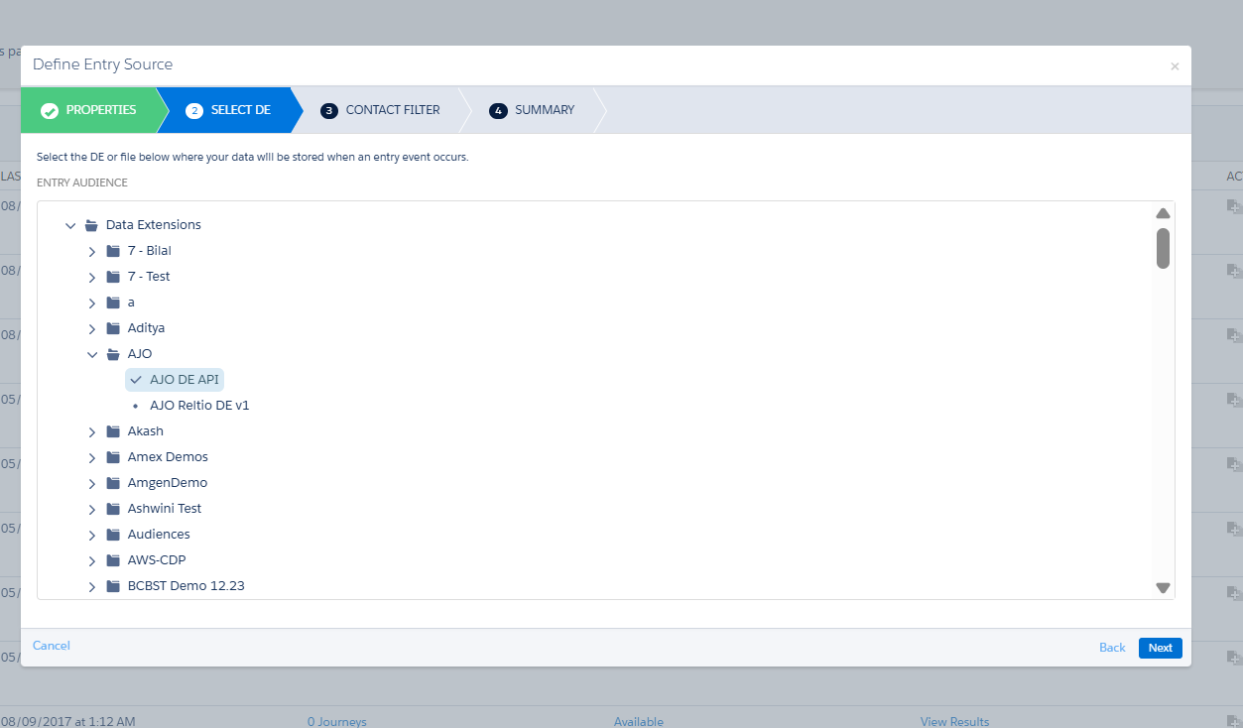

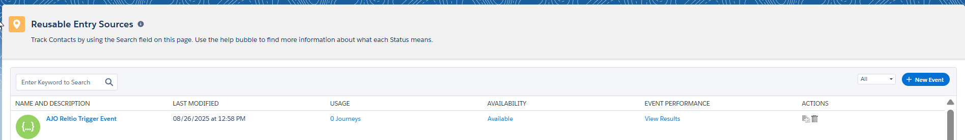

Step 2: Configure journey in SFMC
Build a journey in SFMC with API event as the entry source. This ensures that whenever the event is fired, the journey is triggered immediately.

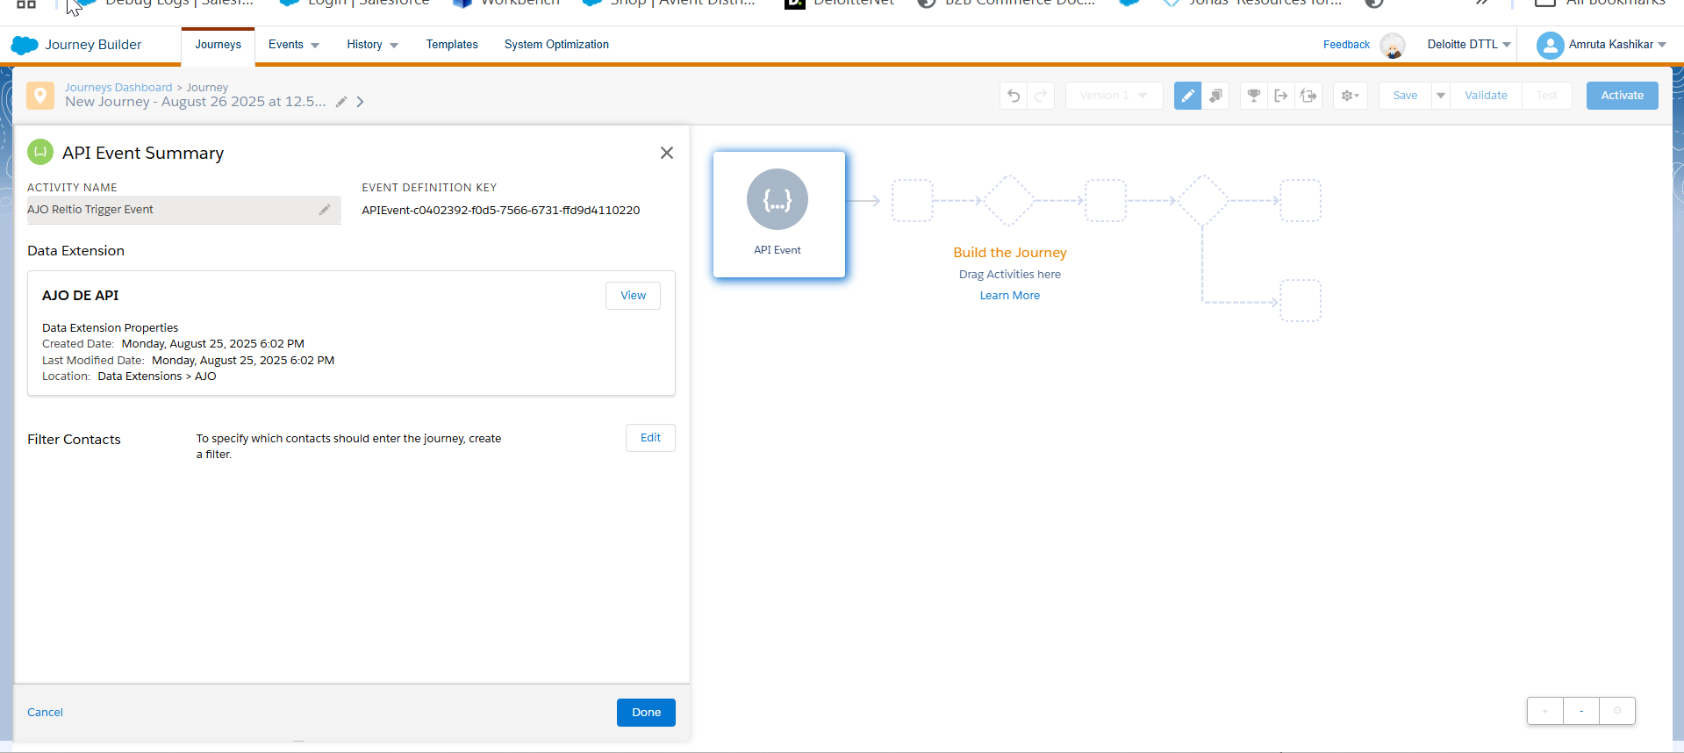
Step 3: Create Custom Action in AJO
Configure a custom action and pass the payload data along with event definition key

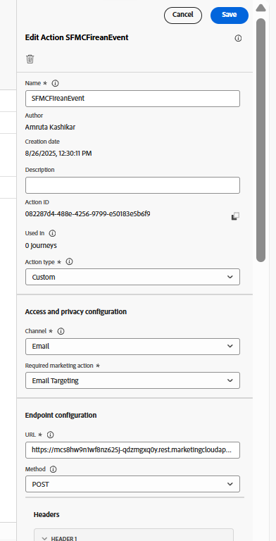

Auth payload
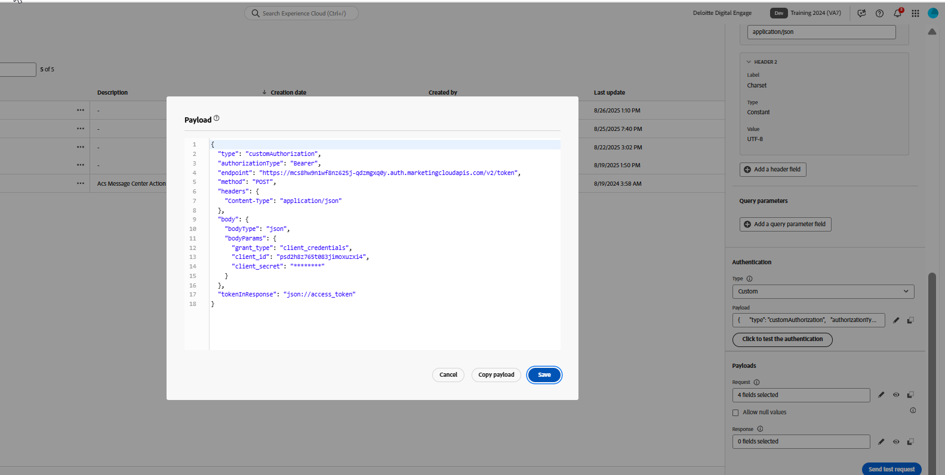

Body
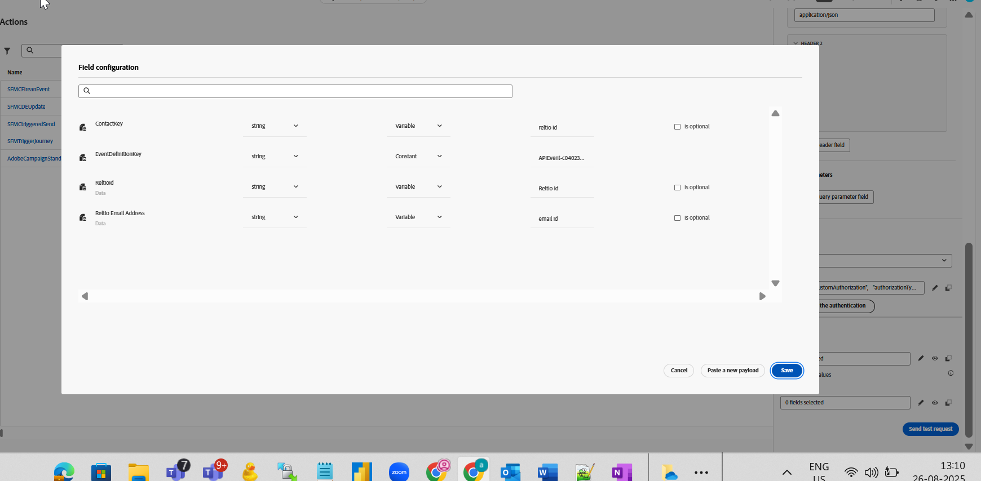

Step 4: Call the custom action from a AJO Journey
Configure an AJO Journey to invoke the custom action. This action will call the SFMC event
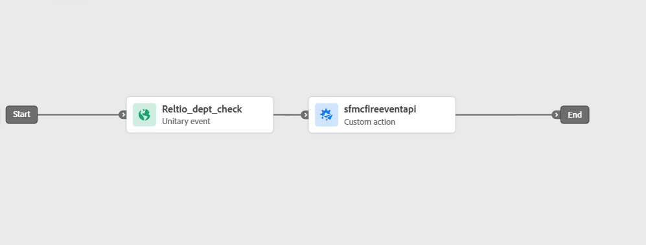

Step 5: Process Records or Triggered an event that will trigger the AJO journey
The below event will trigger the AJO event – Reltio_dept_check and will trigger the AJO journey created above.
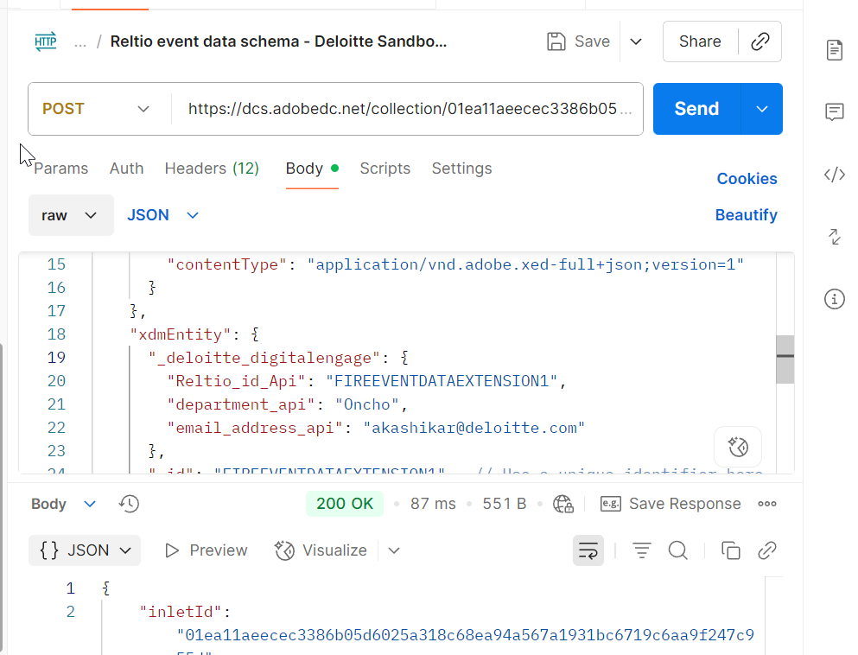

AJO Journey is now triggered
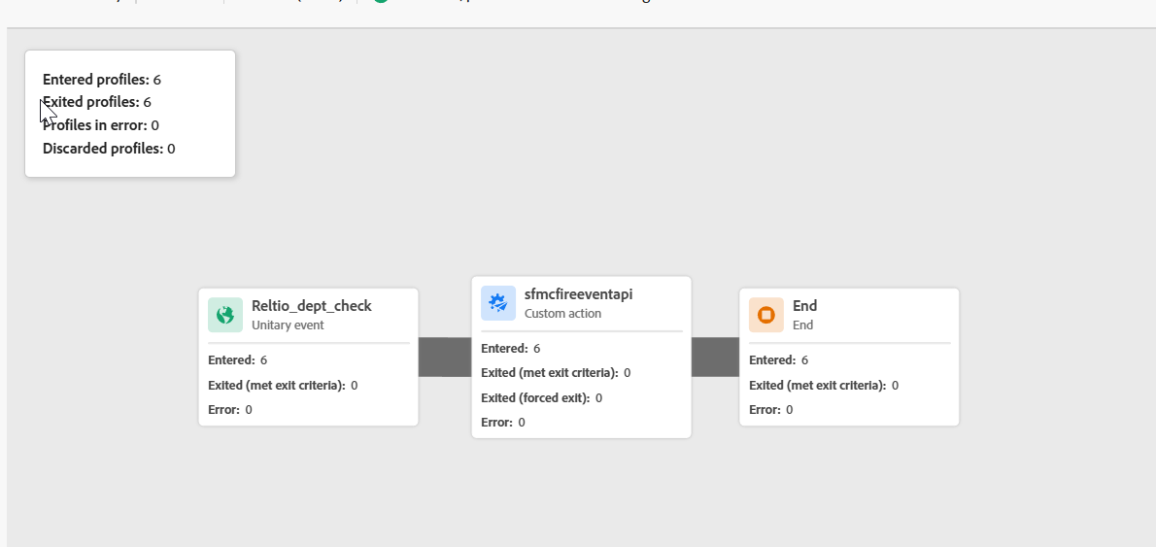

Validate the Data extension linked the Event in SFMC.
New record is ingested- contact key - FIREEVENTDATAEXTENSION1
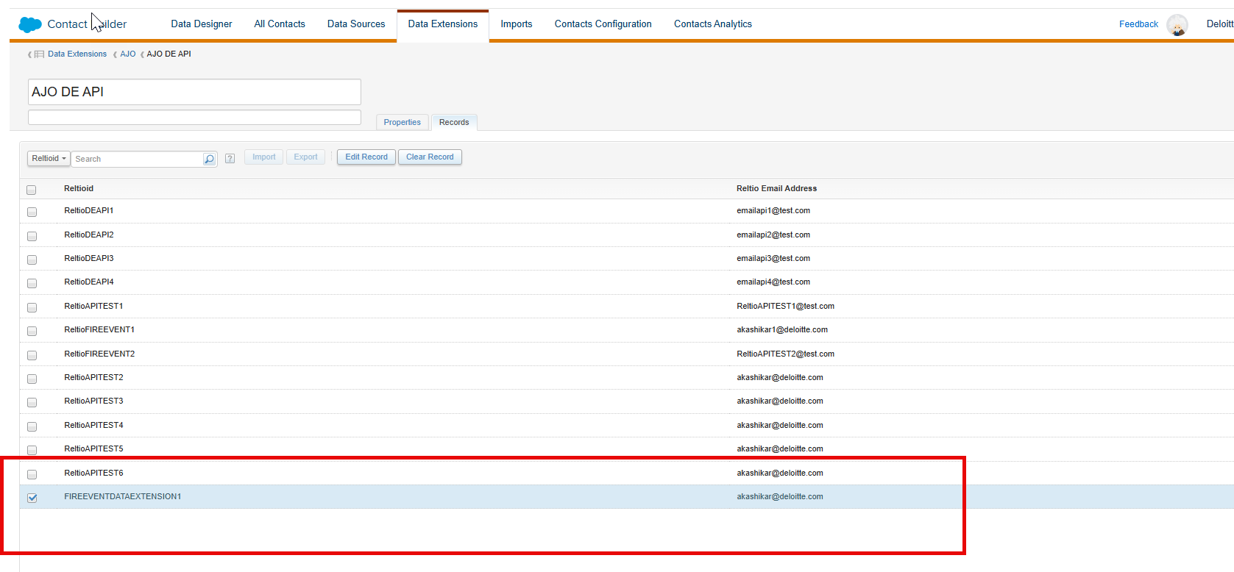

Validate the SFMC journey
